PRT452 ASSIGNMENT 1

Unit Test and Refactoring Questions

Augustine Thorbjornsen s290428

1. Write a program using TDD to do the following (20 marks):

a. This program will generate a random number between 1 to 100. User will be asked to guess the number or enter ‘q’ to quit the program. The program will keep asking the user to guess the number until the user guesses it correctly or has quitted. Once the user has guessed it correctly or quitted, the program will tell the user how many attempts have been taken.

**Steps taken to build this program.**

1. **Think of all possible tests for this program.**
   1. Random number generated between 1 and 100.
   2. User guess must be less than 101
   3. User guess must be greater than 0
   4. Letter q must be only character allowed
   5. To quit program letter q case needs to be ignored.
2. **Create a function that generates a random number only between 1 and 100. Use JUnit to test this function**

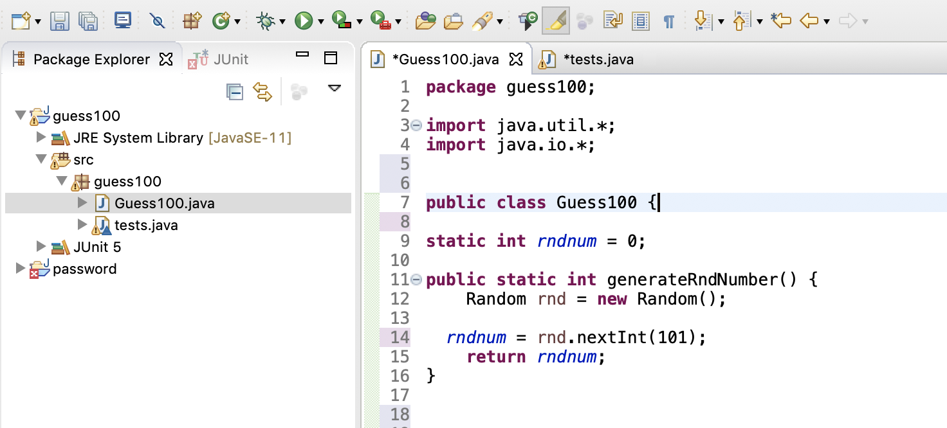

**Test Code/Results : PASSED**

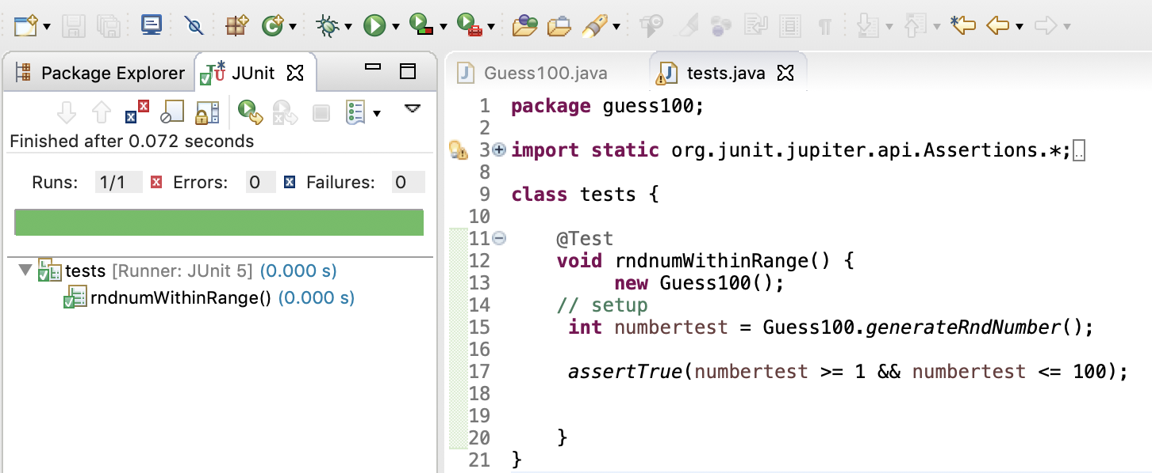

1. **Create two functions to detect if guessed number is greater 100 or lesser than 1. Use JUnit to test these functions.**



**Test Code/Results : PASSED**



1. **Create input buffer reader.**



1. **Create function to detect for letter q, ignore the case and if true quit the program. Use JUnit to test this.**



**Test Code/Results : PASSED**



1. **Create if statement to see if user’s number matches generated number. Output hint to user if user needs to guess lower or higher.**



1. **Wrap this in a Try Catch and output error if user enters a random character.**



1. **Create a Boolean value for game start and finish. Use this in a while loop every time the users guesses.**

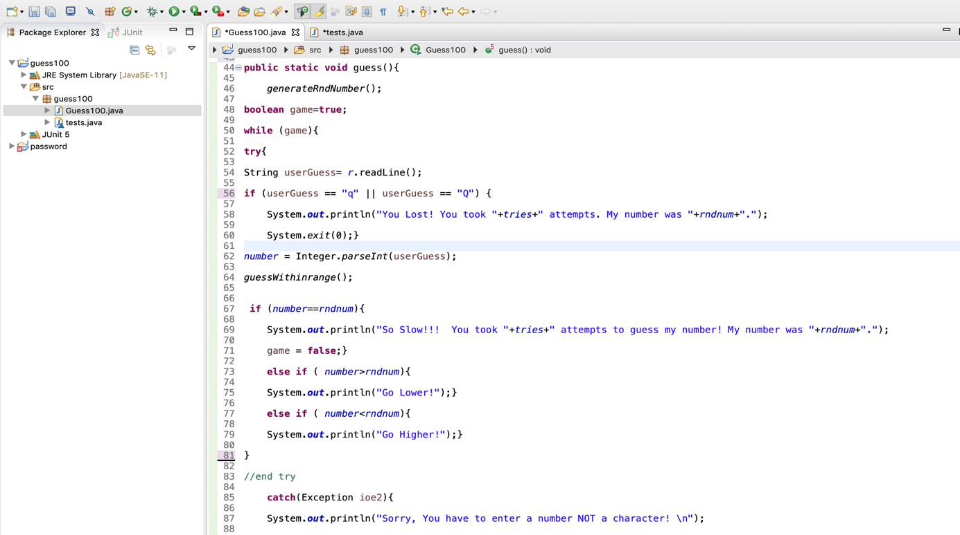

1. **Start the game in main class.**



**Results**



**b.** **Refactor your code – Code smell can give indications that there is some issue with the codes and can be solved by refactoring. Identify issues and their related code smells in your code. Include solutions to fix up the issues and implement them.**

Functions guessGreater() and guessLesser() we’re refactored into 1 function guessWithinrange().

See highlighted area.



Ignore case of letter q refactored using system function.



Using Junit to test guessWithinrange() function.

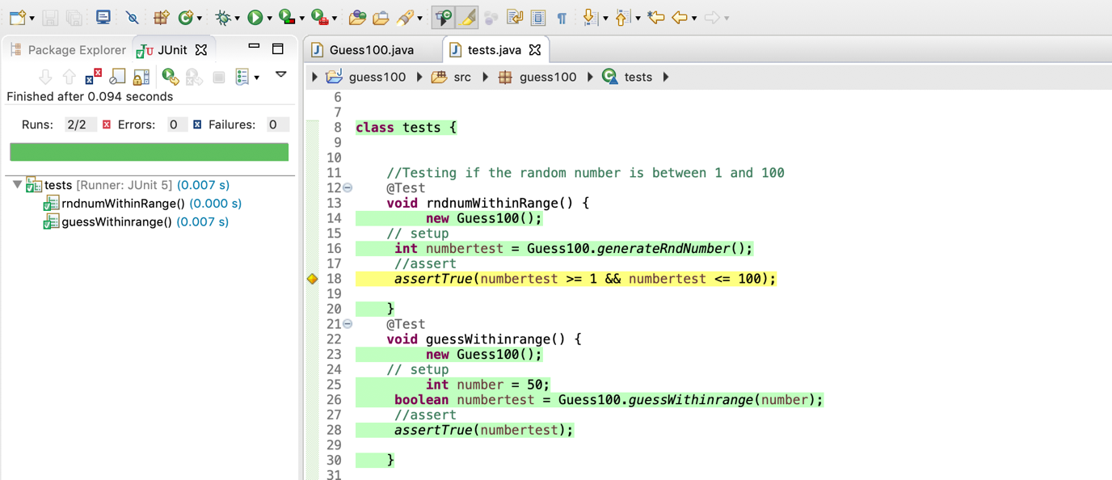

c. Create a Git directory for your assignment (including word or pdf documents and programming code)